**Lab # 09**

**Design of a Light switch**

CSE-308L [DIGITAL SYSTEM DESIGN LAB](https://classroom.google.com/c/NTk1NjYyOTEyNzU5)

**Name: Maaz Habib**

**Reg No: 20PWCSE1952**

**Section: C**

**Submitted to:**

**Engr. M. Usman Malik**

Department of Computer Systems Engineering

University of Engineering and Technology, Peshawar

**Objective**

Build a light switch controller such that when the push button is pressed the light if “off” turns “on” and if “on” turns “off”.

**Lab Task**

Light switch control by push button

**Code**

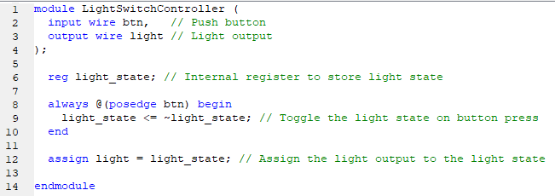

**User Constraint File(ucf)**



**Output**

